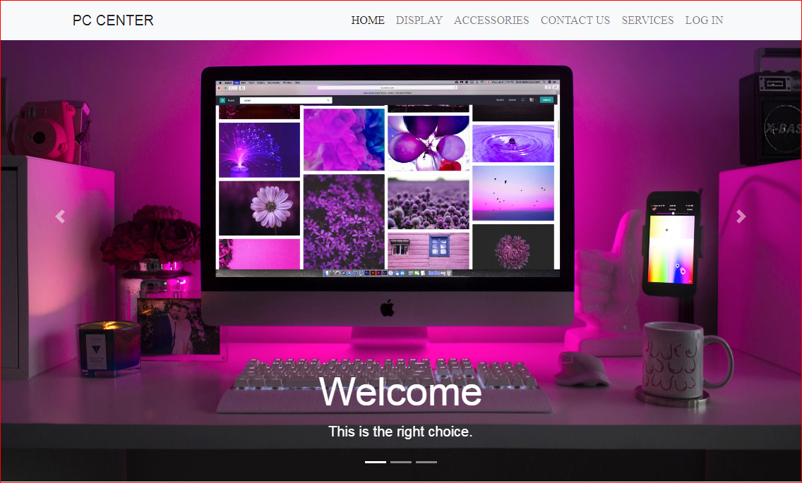

# E - Project Documentation

# Faculty : Sir Tufail Khan

# Batch Co-ordinator : Kiran Nadeem

# Batch Code : 1901B1

**PC CENTER**

**Project Group Members**

Muhammad Husnain

[**Hasnainm206@gmail.com**](mailto:Hasnainm206@gmail.com)

Student Id :

Daniyal Khan

[**Dk720820@gmail.com**](mailto:Dk720820@gmail.com)

Student Id :

Muhammad Moin

[**Moinsahab718@gmail.com**](mailto:Moinsahab718@gmail.com)

**Student Id : 1166953**

**Certification**

**Muhammad Husnain**

[**Hasnainm206@gmail.com**](mailto:Hasnainm206@gmail.com)

**Student Id :** **1166828**

**Daniyal Khan**

[**Dk720820@gmail.com**](mailto:Dk720820@gmail.com)

**Student Id : 1168447**

**Muhammad Moin**

[**Moinsahab718@gmail.com**](mailto:Moinsahab718@gmail.com)

**Student Id : 1166953**

Have successfully designed, developed and submitted:



**PC Center Website**

The date of issued E-project was **05-Apr-2019.**

The date of submission as per given schedule is **05-May-2019.**

**Introduction**



**Introduction**

PC-Centre is a provider of IT products and services in and around the city. With over 2 years experience and a portfolio of over 1,000 products from many leading, manufacturers, they are an independent supplier, offering great deals and best pricing on variety of items, from a massive selection of top brands. Their product range includes hardware, software, peripherals, networking, communications, media, supplies and accessories etc.

In addition, PC-Centre offers home PC installations for consumers and various complementary IT solutions for business including high end enterprise solutions aimed at keeping infrastructures running smoothly.

Post Sales support is the most important aspect of business and they aim to exceed customer’s expectations with a superior level of after-sales technical and customer services. They provide a strong team of qualified Technical Support and Customer Service Advisors to offer advice, assistance and support for any products and solutions purchased from PC-centre.

**Problem definition:**

The PC-centre is very popular in the market and the sale is increasing day by day.

The client visits the shop in order to finalise the deal, but due to the popularity the staff is finding it difficult to handle enquiries and servicing the clients at such a large scale.

The management team hence came out with a solution that the company should have a web site of its own which will host information of the entire business, services provided, products available etc.

You have to develop a web-site which will serve the purpose of PC-centre. The site has to be developed considering the following requirements.

**Requirement specifications:**

A home page with menu that categorizes all the functions of the site.

Sample screen shot of home page is shown below:

PC-Centre is a provider of IT products and services in and around the city. With over 2 years experience and a portfolio of over 1,000 products from many leading, manufacturers, they are an independent supplier, offering great deals and best pricing on variety of items, from a massive selection of top brands. Their product range includes hardware, software, peripherals, networking, communications, media, supplies and accessories etc.

In addition, PC-Centre offers home PC installations for consumers and various complementary IT solutions for business including high end enterprise solutions aimed at keeping infrastructures running smoothly.

Post Sales support is the most important aspect of business and they aim to exceed customer’s expectations with a superior level of after-sales technical and customer services. They provide a strong team of qualified Technical Support and Customer Service Advisors to offer advice, assistance and support for any products and solutions purchased from PC-centre.

**Problem definition:**

The PC-centre is very popular in the market and the sale is increasing day by day.

The client visits the shop in order to finalise the deal, but due to the popularity the staff is finding it difficult to handle enquiries and servicing the clients at such a large scale.

The management team hence came out with a solution that the company should have a web site of its own which will host information of the entire business, services provided, products available etc.

You have to develop a web-site which will serve the purpose of PC-centre. The site has to be developed considering the following requirements.

**Requirement specifications:**

A home page with menu that categorizes all the functions of the site.

Sample screen shot of home page is shown below:

**Standards plan:**

**USE OF DATABASE IS NOT MANDATORY. YOU CAN DEVELOP STATIC WEB PAGES**.

Every code block must have comments.

The logic of the program needs to be explained. Proper documentation should be maintained.

Complete Project Report along with synopsis, code and documentation should be prepared.

**Documentation:**

No project is complete without documentation. In fact, it is one of the most important activities during the development of a project. The documentation of an ideal project will be in the form of a project report comprising of the following documents:

* Certificate of Completion.
* Table of Contents.
* Problem Definition.
* Customer Requirement Specification.
* Project Plan.
* E-R Diagrams.
* Algorithms.
* GUI Standards Document.
* Interface Design Document.
* Task Sheet.
* Project Review and Monitoring Report.
* Unit Testing Check List.
* Final Check List.

**Project Duration**

Analysis-18 Hrs.

Design – 22 Hrs.

Development –20Hrs

Testing – 12 Hrs

Documentation -11 hrs

|  |  |  |  |  |
| --- | --- | --- | --- | --- |
| *No* | *Task* | *Actual Start Date* | *Actual Days* | *Team Mate Name* |
| 1 | Analysis | 5-Apr-2019 | 2 | M.Husnain  Daniyal Khan  M.Moin |
| 2 | Design | 12- Apr -2019 | 8 | M.Husnain  Daniyal Khan  M.Moin |
| 3 | Development | 20- Apr -2019 | 8 | M.Husnain  Daniyal Khan |
| 4 | Testing | 25- Apr -2019 | 5 | M.Husnain  Daniyal Khan |
| 5 | Documentation | 28- Apr -2019 | 3 | M.Husnain  Daniyal Khan  M.Moin |
| 6 | Finalization | 4- May -2019 | 6 | M.Husnain  Daniyal Khan  M.Moin |

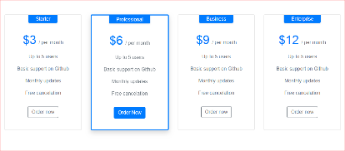

**HOME PAGE**



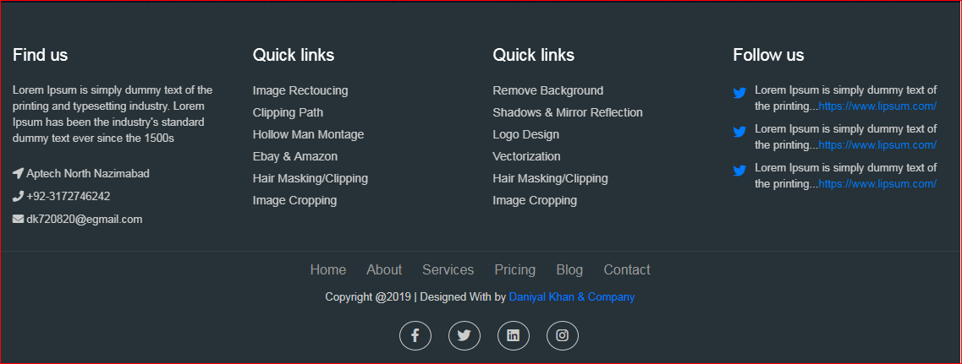

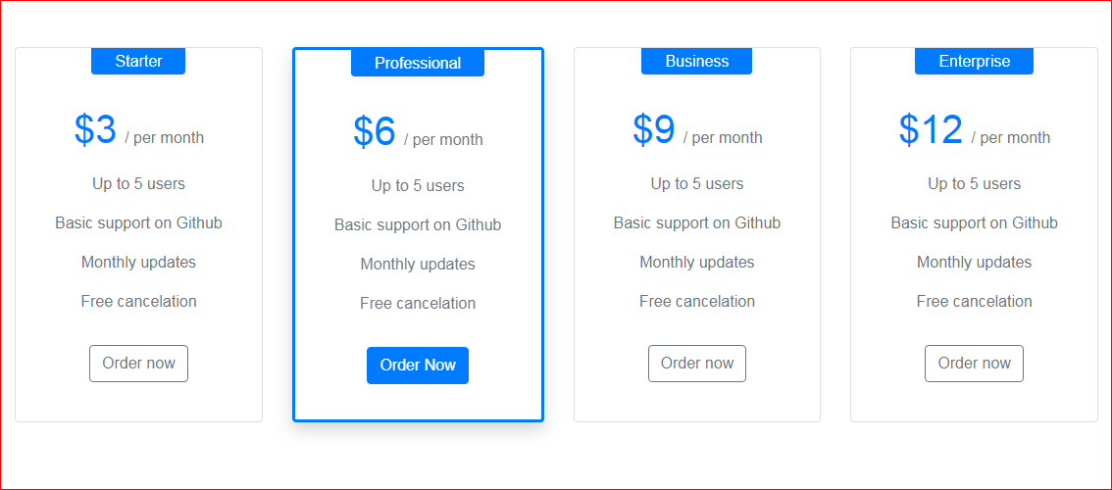

DISPLAY

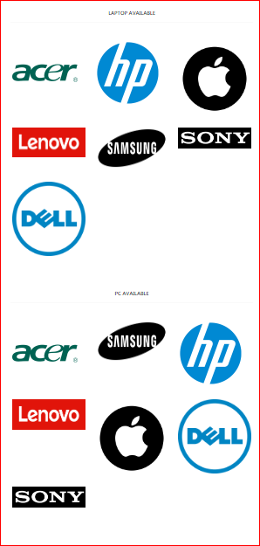

Accessories

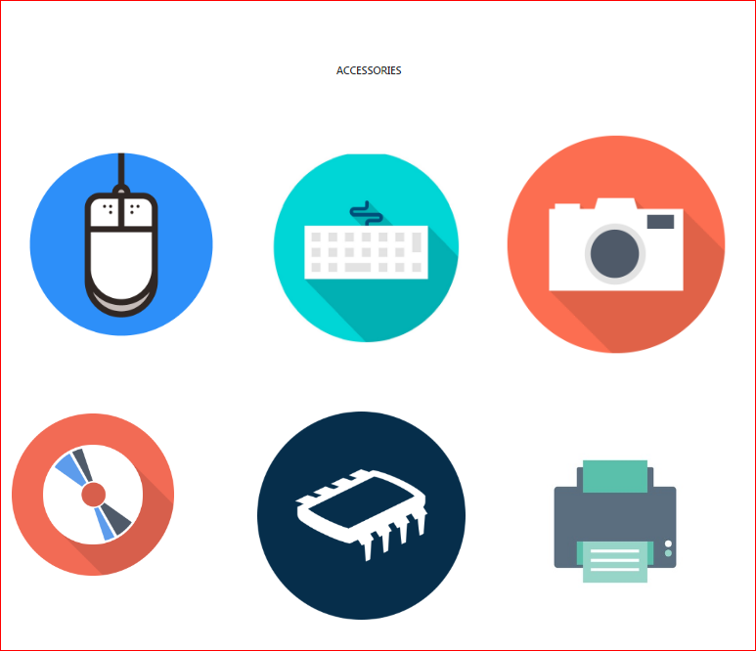

Log in form

**

Registration form

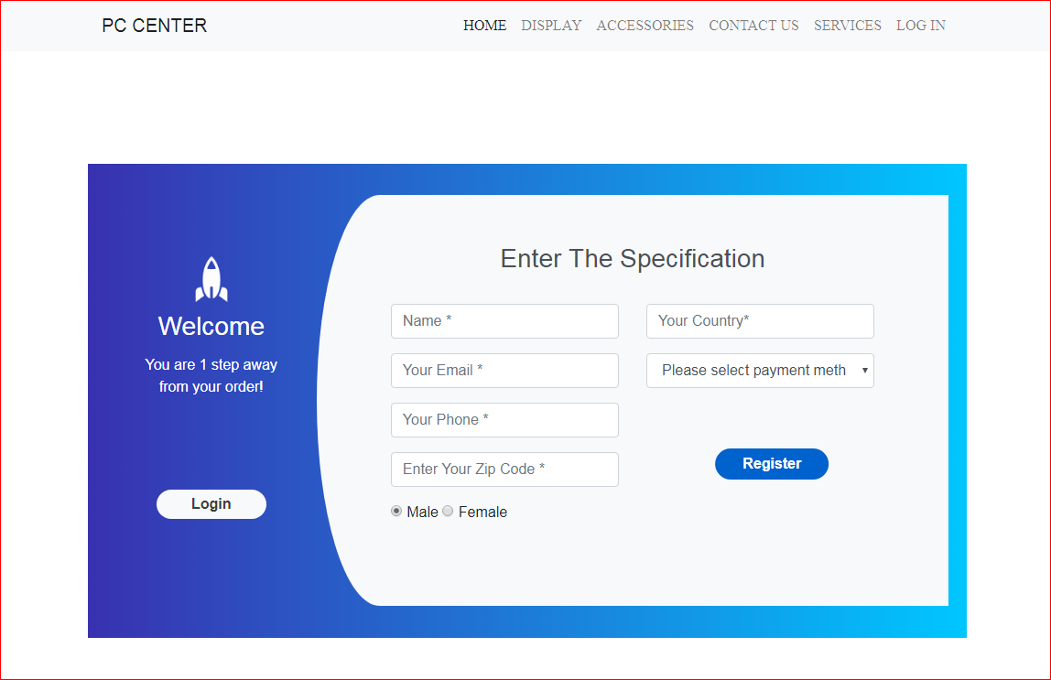

PRODUCT, S

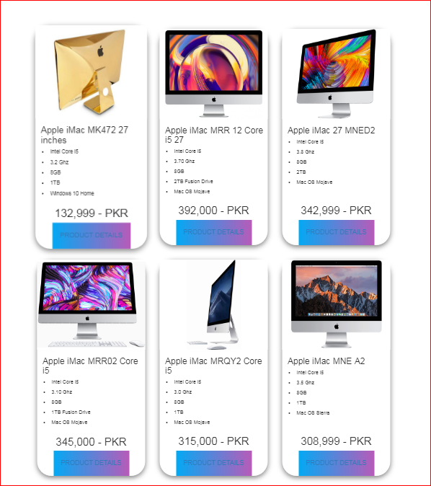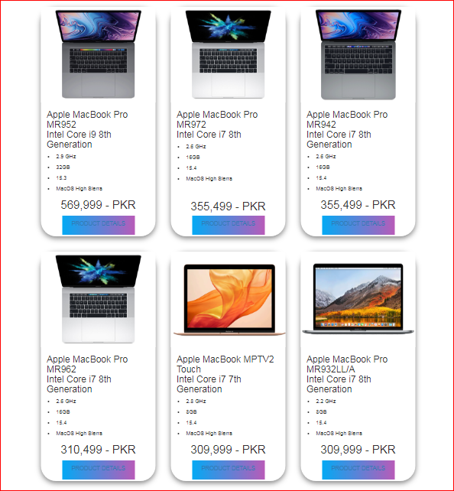

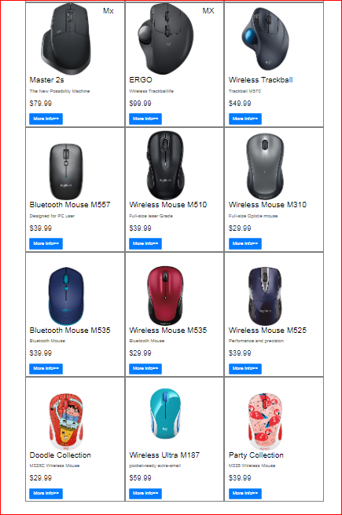

Product is the item offered for sale. A productcan be a service or an item

Every product is made at a cost and each is sold at a price



PRODUCT,S DETAIL,S



